Experiment 7.2
Fourier Series of Half-Wave Rectifier Output
Aim:
To compute and analyze the Fourier series representation of the output of a half-wave rectifier. The Aim is to understand how the Fourier series can decompose a non-sinusoidal periodic signal into its constituent sinusoidal components (harmonics), and to observe how these harmonics contribute to the overall signal.
Program:
% Fourier Series of Half-Wave Rectifier Output
clc;
clear;
close all;
% Time axis
t = 0:0.001:2*pi;
% Half-wave rectified signal
x = sin(t);
x(x < 0) = 0;
% Fourier Series approximation
N = 10; % Number of harmonics
a0 = (1/pi)*trapz(t,x);
fs_signal = a0/2;
for n = 1:N
an = (1/pi)*trapz(t,x.*cos(n*t));
bn = (1/pi)*trapz(t,x.*sin(n*t));
fs_signal = fs_signal + an*cos(n*t) + bn*sin(n*t);
end
% Plotting
figure;
subplot(2,1,1);
plot(t,x,'LineWidth',2);
grid on;
title('Half-Wave Rectified Signal');
xlabel('Time');
ylabel('Amplitude');
subplot(2,1,2);
plot(t,fs_signal,'LineWidth',2);
grid on;
title('Fourier Series Approximation');
xlabel('Time');
ylabel('Amplitude');
Output Waveform:
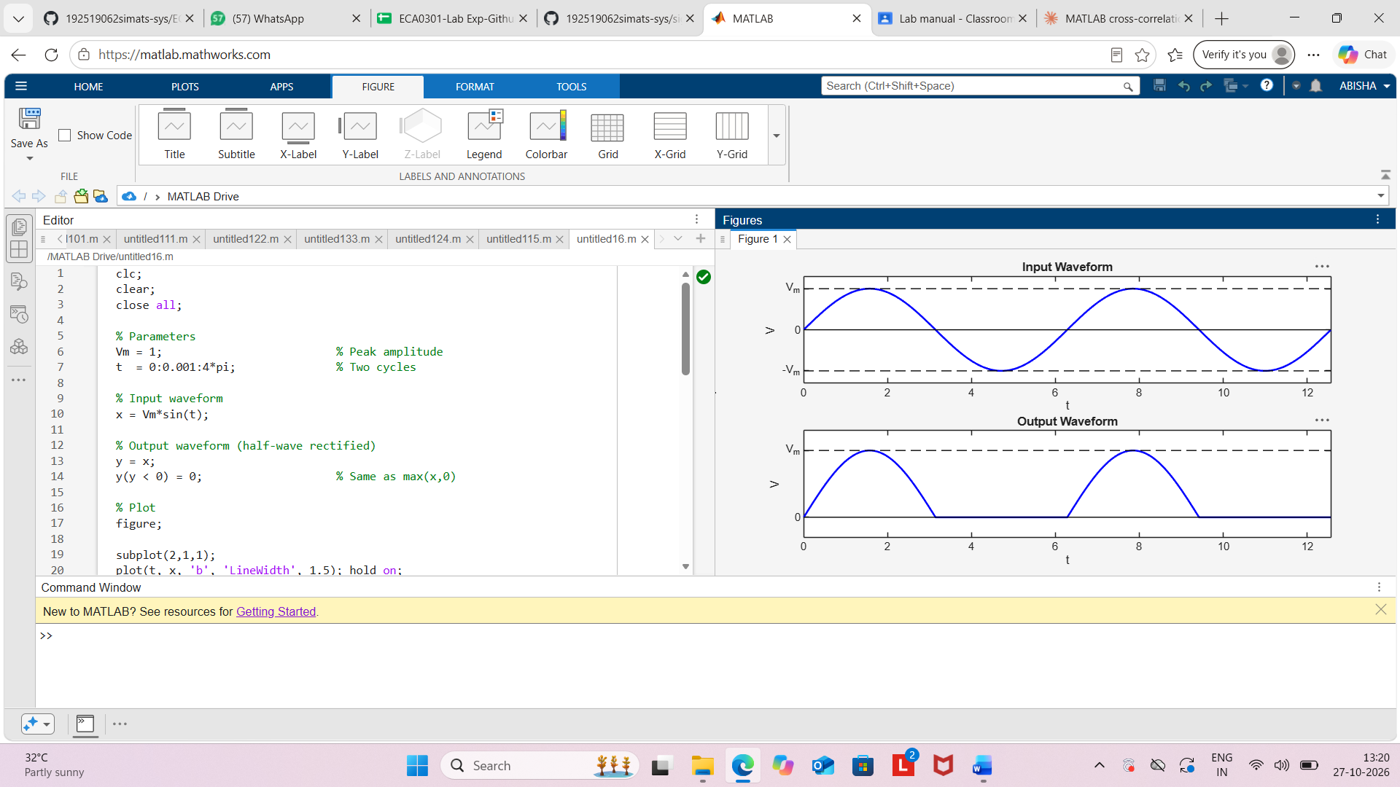
Result:
The Fourier Series of the half-wave rectified signal was obtained using MATLAB. The
reconstructed waveform using Fourier coefficients closely matched the original half-wave
rectified signal, demonstrating the Fourier Series representation of periodic signals.

